**EXERCISE 3: STORED PROCEDURE**

**CODE:**

**CREATING TABLES FOR THAT SCENARIO:**

BEGIN  
EXECUTE IMMEDIATE 'DROP TABLE accounts';  
EXECUTE IMMEDIATE 'DROP TABLE employees';  
EXCEPTION  
WHEN OTHERS THEN NULL;  
END;  
/

-- Accounts Table  
CREATE TABLE accounts (  
account_id NUMBER PRIMARY KEY,  
customer_id NUMBER,  
account_type VARCHAR2(20),  
balance NUMBER  
);

-- Employees Table  
CREATE TABLE employees (  
emp_id NUMBER PRIMARY KEY,  
name VARCHAR2(100),  
department VARCHAR2(50),  
salary NUMBER  
);

-- Sample Data  
INSERT INTO accounts VALUES (101, 1, 'savings', 1000);  
INSERT INTO accounts VALUES (102, 1, 'savings', 2000);  
INSERT INTO accounts VALUES (103, 2, 'checking', 3000);

INSERT INTO employees VALUES (1, 'John', 'IT', 5000);  
INSERT INTO employees VALUES (2, 'Jane', 'HR', 4000);  
INSERT INTO employees VALUES (3, 'Bob', 'IT', 5500);

COMMIT;

**SCENARIO 1:**

CREATE OR REPLACE PROCEDURE ProcessMonthlyInterest IS  
BEGIN  
UPDATE accounts  
SET balance = balance + (balance * 0.01)  
WHERE account_type = 'savings';

COMMIT;  
END;  
/

**RUN THE PROCEDURE**:

BEGIN  
ProcessMonthlyInterest;  
END;  
/

Check result:

SELECT * FROM accounts;

**OUTPUT:**

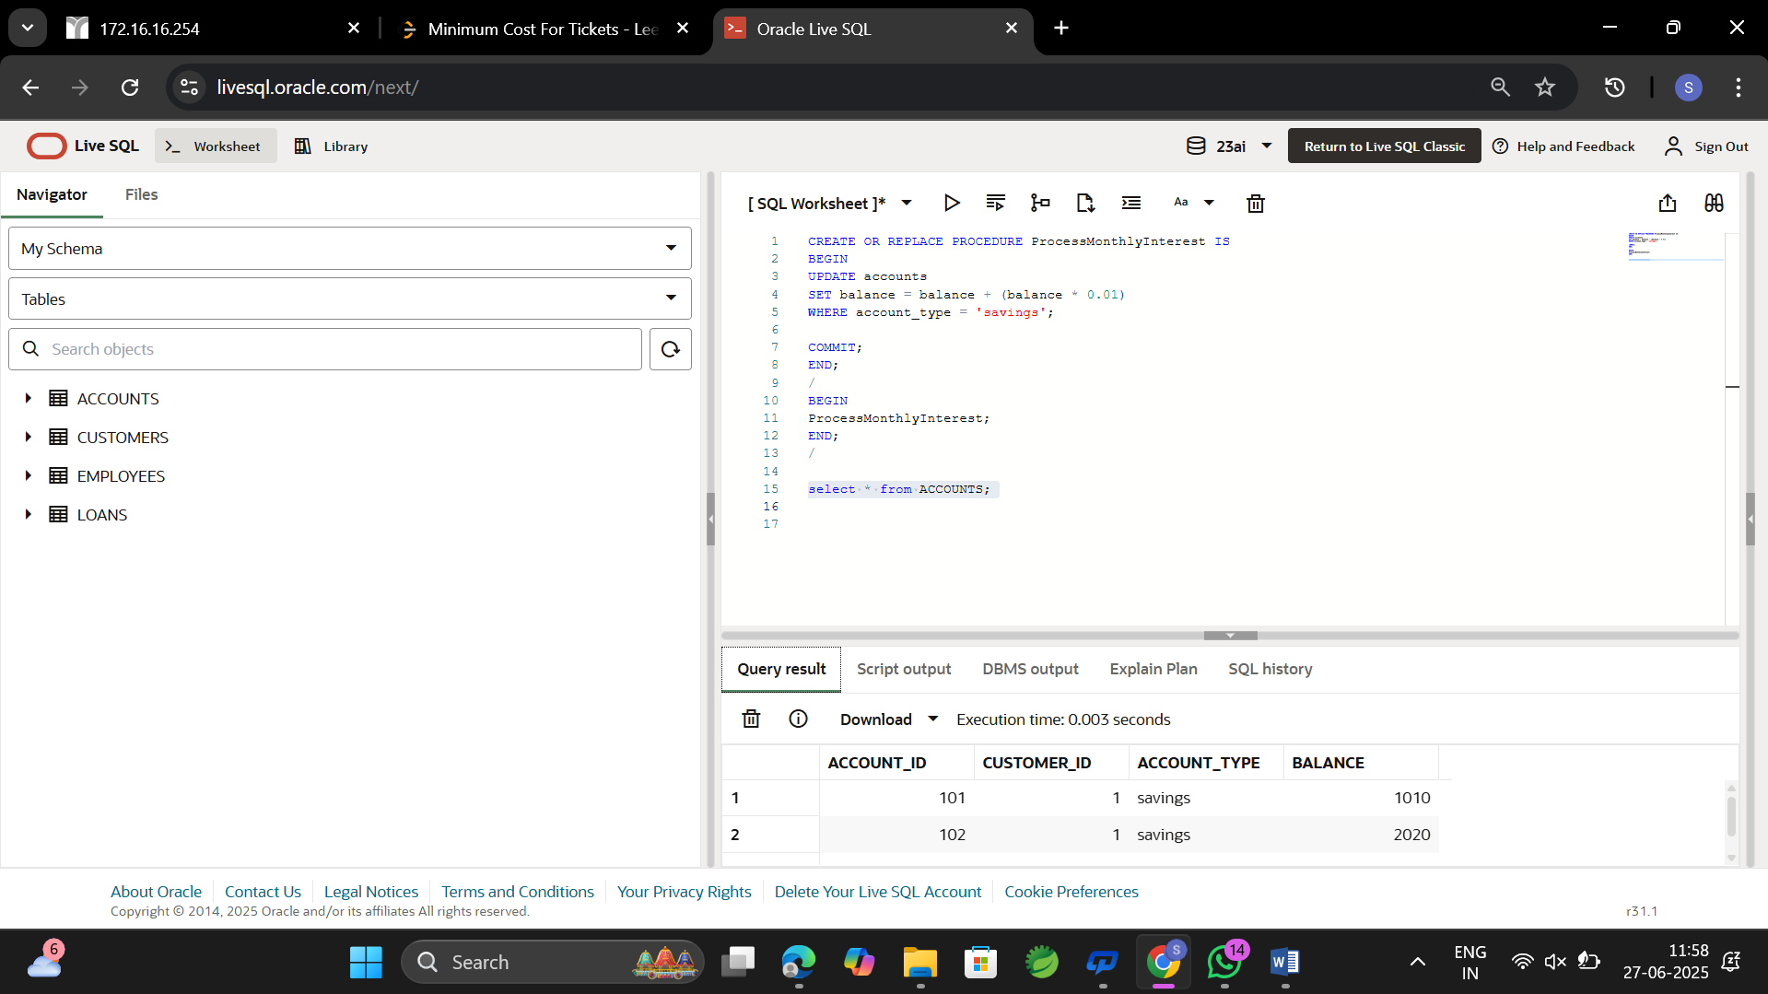

**SCENARIO 2:**

CREATE OR REPLACE PROCEDURE UpdateEmployeeBonus(  
dept_name IN VARCHAR2,  
bonus_pct IN NUMBER  
) IS  
BEGIN  
UPDATE employees  
SET salary = salary + (salary * bonus_pct / 100)  
WHERE department = dept_name;

COMMIT;  
END;  
/

**Run the procedure :**

BEGIN  
UpdateEmployeeBonus('IT', 10);  
END;  
/

Check result:

SELECT * FROM employees;

**OUTPUT:**

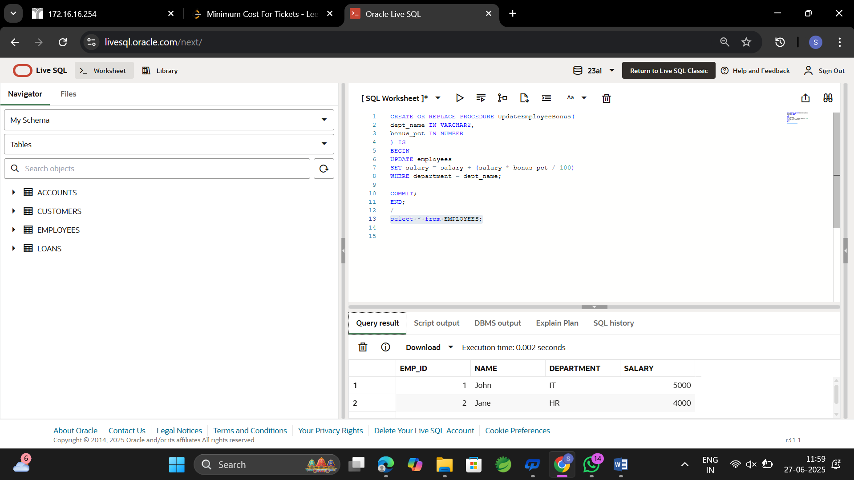

**SCENARIO 3:**

CREATE OR REPLACE PROCEDURE TransferFunds(  
from_acct IN NUMBER,  
to_acct IN NUMBER,  
amount IN NUMBER  
) IS  
insufficient_balance EXCEPTION;  
BEGIN  
-- Check balance  
DECLARE  
from_balance NUMBER;  
BEGIN  
SELECT balance INTO from_balance FROM accounts WHERE account_id = from_acct;

nginx

CopyEdit

IF from_balance < amount THEN

RAISE insufficient_balance;

END IF;

END;

-- Perform transfer  
UPDATE accounts  
SET balance = balance - amount  
WHERE account_id = from_acct;

UPDATE accounts  
SET balance = balance + amount  
WHERE account_id = to_acct;

COMMIT;

EXCEPTION  
WHEN insufficient_balance THEN  
DBMS_OUTPUT.PUT_LINE('Transfer failed: Insufficient balance');  
ROLLBACK;  
WHEN OTHERS THEN  
DBMS_OUTPUT.PUT_LINE('Transfer failed: ' || SQLERRM);  
ROLLBACK;  
END;  
/

**Run the procedure :**

BEGIN  
TransferFunds(102, 103, 500);  
END;  
/

SELECT * FROM accounts;

**OUTPUT:**

